AIM :
To develop a terminal-based ATM Simulation program in Java using Object-Oriented Programming (OOP) concepts, where a user can log in using a User ID and PIN, and perform basic banking operations such as checking balance, depositing money, and withdrawing money.
PROCEDURE :
- Create a class ATM to represent ATM operations.
- Declare private arrays to store:
  - User IDs
  - PIN numbers
  - Account balances
- Initialize sample user data inside the class.
- Use a Scanner object to accept user input from the terminal.
- Ask the user to enter User ID and PIN.
- Validate the entered credentials by comparing them with stored arrays.
- If authentication fails, display an error message and terminate the program.
- If authentication is successful:
  - Display a menu with options:
    - Check Balance
    - Deposit
    - Withdraw
    - Exit
- Use a do-while loop to repeatedly show the menu until the user chooses Exit.
- Use a switch statement to perform operations based on user choice:
  - Check Balance: Display the current balance.
  - Deposit: Add the entered amount to the balance.
  - Withdraw: Subtract the entered amount if sufficient balance is available.
  - Exit: Terminate the program safely.
- Create a separate class ATMSimulation containing the main() method.
- Create an object of the ATM class and call the start() method to begin execution.
PROGRAM (Java Code) :
import java.util.Scanner;
class ATM {
private int[] userIds = {101, 102, 103};
private int[] pins = {1111, 2222, 3333};
private double[] balances = {5000, 10000, 7500};

private int currentUserIndex = -1;

void start() {
Scanner sc = new Scanner(System.in);

System.out.print("Enter User ID: ");
int enteredId = sc.nextInt();

System.out.print("Enter PIN: ");
int enteredPin = sc.nextInt();

for (int i = 0; i < userIds.length; i++) {
if (userIds[i] == enteredId && pins[i] == enteredPin) {
currentUserIndex = i;
break;
}
}

if (currentUserIndex == -1) {
System.out.println("Invalid User ID or PIN");
return;
}

int choice;
do {
System.out.println("\n1. Check Balance");
System.out.println("2. Deposit");
System.out.println("3. Withdraw");
System.out.println("4. Exit");
System.out.print("Enter choice: ");

choice = sc.nextInt();

switch (choice) {

case 1:
System.out.println("Balance: Rs." + balances[currentUserIndex]);
break;

case 2:
System.out.print("Enter deposit amount: ");
double deposit = sc.nextDouble();
if (deposit > 0) {
balances[currentUserIndex] += deposit;
System.out.println("Updated Balance: Rs." + balances[currentUserIndex]);
} else {
System.out.println("Invalid amount");
}
break;

case 3:
System.out.print("Enter withdrawal amount: ");
double withdraw = sc.nextDouble();
if (withdraw > 0 && withdraw <= balances[currentUserIndex]) {
balances[currentUserIndex] -= withdraw;
System.out.println("Updated Balance: Rs." + balances[currentUserIndex]);
} else {
System.out.println("Insufficient balance");
}
break;

case 4:
System.out.println("Exit Successful");
break;

default:
System.out.println("Invalid choice");
}

} while (choice != 4);

sc.close();
}
}
public class ATMSimulation {
public static void main(String[] args) {
new ATM().start();
}
}
OUTPUT:
I ) Cheak Balance
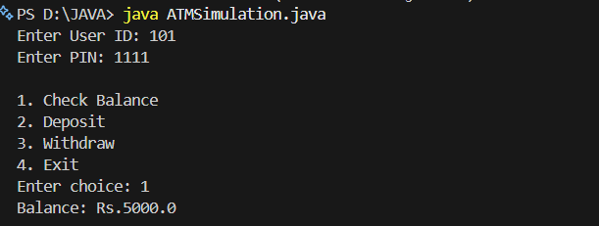
II ) Deposit
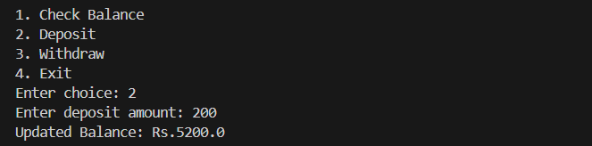
III ) Withdraw
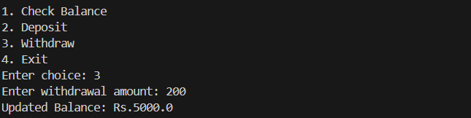
IV ) Exit
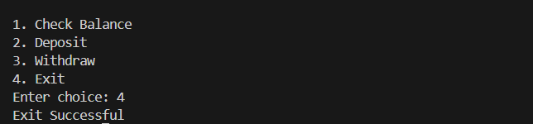
RESULT :
The ATM Simulation program was successfully executed.

